Volunteering with PANDAS

Who we are:
The PANDAS Foundation (PANDAS) provides support, advice, and a voice for those coping with perinatal mental illness. PANDAS provide in-person, telephone, and virtual safe environments for peers to support one another at this crucial time, often providing the first step in an individual’s recovery. Since its formation in 2011, PANDAS has supported over 40,000 parents. These are people who were suffering a range of perinatal mental illnesses, including depression, anxiety, psychosis, OCD, intrusive thoughts, eating disorders, and self-harm.

Our motto:
‘We are here, whatever the weather, to offer hope, empathy and support for every parent or network affected by perinatal mental illness.’

Our aim:
‘To be the UK’s most recognised and trusted support service for families and their networks who may be suffering with perinatal mental illness, including prenatal (antenatal) and postnatal depression.

What we are looking for in volunteers:
We need dedicated PANDAS volunteers who are able and willing to work from their home or in their community. As a PANDAS volunteer you will provide support, information, and a listening ear to individuals with pre or postnatal illnesses, and to those seeking help on their behalf. You do not need to be a parent but have a strong interest in parenting from conception through to birth and beyond and the challenges that they may face. PANDAS volunteers provide a service to people who may be vulnerable, therefore you will need to be compassionate, empathetic, and able to maintain confidentiality.

What does our organisation look like:

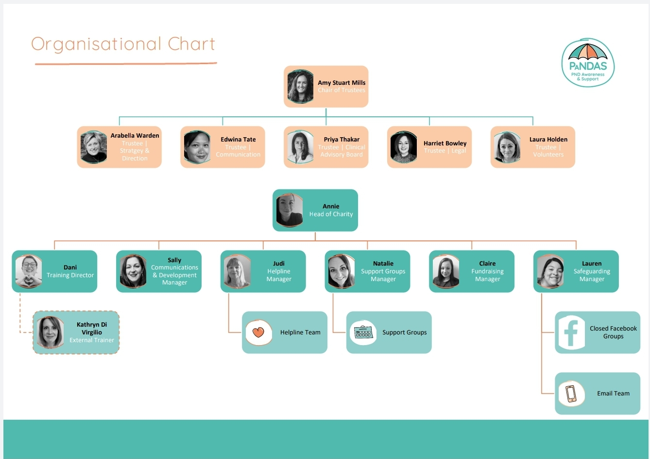

What PANDAS will offer you as a volunteer:
People volunteer with PANDAS for a variety of reasons. Whatever your reason we are happy to have you. Below are some reasons we think you could volunteer with us:
- Opportunity – the opportunity to volunteer in the UKs most recognised and trusted support service for families suffering from perinatal mental health issues and their wider support networks.
- Training – we have a dedicated training director who regularly sources new training opportunities that will benefit the wider charity. We currently provide volunteers with Safeguarding Training, Institute of Health Visiting (iHV) Perinatal and infant mental health champions training and Birth Trauma Training.
- Making a difference – you will make a positive difference to people’s lives when they need it most.
- Support- Our volunteers are as important to us as the people we support with this, we have a wellbeing policy for every volunteer, with regular check ins to see how you are, gain any feedback and also support your own individual needs.
- Personal growth – volunteering with PANDAS allows you to spend time carrying out activities you may not have done previously, talking to people you may not have met otherwise, gaining, or improving skills and confidence, and feeling like a valued member of the PANDAS team.

What areas do we require volunteers and what each role involves:
Helpline – Our helpline is available Monday to Sunday, 11am – 10pm with each day split into hourly shifts, we will require you to undertake at least 3 hours a week (all at once or spread out). You will be fully supported by your team manager throughout your time on the helpline. Shifts are subject to availability and the team manager will provide you with the rota prior to starting, to ensure there is a time that you can volunteer.
Email – Our email support team are available Monday to Sunday, 8am – 10pm with each day being split into 3 shifts (morning 8am-12pm, afternoon 12pm-5pm and evening 5pm-10pm). You will be responsible for regularly checking the email account during your allocated shift and responding to new emails. You will also be responding to emails from service users you have previously been in contact with out with these shifts. Each email must be responded to within 72 hours. You will be informed via the PANDAS Email Support WhatsApp group that you have outstanding emails. You will be fully supported by your team manager throughout your time on the email support team. Shifts are subject to availability and the team manager will provide you with the rota prior to starting, to ensure there is a time that you can volunteer.
Closed Facebook groups – We currently have 2 closed Facebook groups providing support (one for mums and one for dads). Both groups are monitored Monday to Sunday, 8am – 10pm. We will require you to undertake at least 2 hours a week (all at once or spread out). Shifts are subject to availability and the team manager will provide you with the rota prior to starting, to ensure there is a time that you can volunteer.
Face to Face Support Groups - PANDAS Support Groups are perhaps the most unique way of gaining support through the charity, due to the face to face contact that group members can experience. Support Groups are there as a safe space, with no judgement. Each individual group will find their own way of running, which suits their members needs and interests. The groups are usually informal and a way for members to build relationships whilst receiving genuine support from people who understand. There is a lot of autonomy in running your group. Group leaders need to arrange suitable facilities in their local area and promote the group locally as appropriate.
On call language specialists – Every so often we are contacted by service users who speak languages other than English. To allow PANDAS to provide the best support possible to everyone who asks for it we are looking for volunteers who speak other languages. If you are fluent in any languages other than English and would be happy to provide support in that language, please do make us aware on your expression of interest form. We are also collating a database of volunteers who could be called upon to offer support in their chosen language. You will be trained to support service users via email, the helpline and on our closed Facebook group and will be asked to step in and support as and when required.

Requirements of your role as a volunteer with PANDAS:
- It is imperative that you have an interest, lived or work experience of perinatal mental health issues.
- It is imperative you know when to act on safeguarding concerns, in line with all PANDAS policies.
- You must be able to work a minimum of 2 hours per week (some areas will require more) for at least a 6-month period.
- All our volunteers must have an up-to-date enhanced Disclosure and Barring Service (DBS) check.
- Must be willing to join a dedicated volunteer team WhatsApp group.
- Enable service users to have a safe space to discuss how they are feeling.
- If you are a healthcare professional, you must NOT act in that capacity within your role as a PANDAS volunteer.
- Signpost service users appropriately to other PANDAS service areas, NHS, or local organisations.
- You will be compassionate, empathetic and ensure the confidentiality of all service users, volunteers and staff are maintained in line with GDPR and our most up to date policies.
- You will, with the training and support provided by PANDAS, have the capability to discuss sensitive topics raised by service users.
- You must engage with supervision from your department line manager and take part in regular wellbeing check ins with the safeguarding manager.
- You must notify your line manager if you become mentally or physically unwell, to enable us to provide YOU with adequate support, and to allow the team to continue meeting service user’s needs.
- You will complete all necessary training to enable you to provide a safe environment or our service users to talk openly.
- Understand and agree to follow all PANDAS policies.

Next Steps:
You will be required to fill in an expression of interest form, undertake a brief interview, training, and DBS check before you begin volunteering with PANDAS. You will be fully supported by a team manager throughout your time as a volunteer, receive information on all training provided that may assist you in undertaking your role and you will receive quarterly wellbeing check ins.

To start your volunteer journey with PANDAS please complete the expression of interest form, and we look forward to you joining the PANDAS team.

